Name: _______________________ Class: __________ Date: _______
Instructions: Write answers in the right-hand column. Score: ___________ / 30 marks

Section A—Multiple choice (10 marks)

 | Which one of the following statements contains two correct descriptions of oxidation?  A addition of electrons, decrease in oxidation number  B removal of electrons, decrease in oxidation number  C addition of electrons, increase in oxidation number  D removal of electrons, increase in oxidation number. | D | 1
 | Which of the following statements is false?  A The reactant from which electrons are taken is reduced.  B Oxidation involves an increase in oxidation state.  C A reductant undergoes oxidation.  D In reduction half equations, the electrons appear on the left hand side (reactant side) of the equation. | A | 1
 | Which one of the following is the best definition of an oxidant?  An oxidant:  A always contains oxygen  B causes the oxidation of another substance  C is oxidised during reactions  D donates electrons to another substance. | B | 1
 | In the following reaction: H₂S(g) + Br₂(aq) → S(s) + 2H⁺(aq) + 2Br–(aq)  A H₂S is oxidised  B Br₂ is the reductant  C H₂S has undergone reduction  D neither H₂S nor Br₂ have been reduced or oxidised. | A | 1
 | In which of the following species is vanadium exhibiting the highest oxidation number?  A VO²⁺  B NH₄VO₃  C V₂(SO₄)₃  D VBr₄ | B | 1
 | Which of the following reactions is a redox reaction?  A CaCO₃(s) → CaO(s) + CO₂(g)  B Pb²⁺(aq) + 2Br–(aq) → PbBr₂(s)  C 2H⁺(aq) + HCO₃–(aq) → CO₂(g) + H₂O(l)  D MnO₄–(aq) + 5Fe²⁺(aq) + 8H⁺(aq) → Mn²⁺(aq) + 5Fe³⁺(aq) + 4H₂O(l) | D | 1
 | Which equation shows the disproportionation of chlorine (i.e. chlorine acts as both the oxidant and the reductant)?  A Cl₂(aq) + H₂O(l) → H⁺(aq) + Cl–(aq) + HClO(aq)  B Cl₂(g) + 2e– → 2Cl–(aq)  C Cl₂(g) + H₂(g) → 2HCl(g)  D Cl₂(aq) + 2H₂O(l) → 2HClO(aq) + 2H⁺(aq) + 2e– | A | 1
 | During the electrolysis of a molten salt, which one of the following statements is false?  A Reduction takes place at the cathode.  B The positive electrode is the anode.  C Electrons flow from the negative terminal of the power source into the cathode.  D The positive ions in the electrolyte flow towards the anode. | D | 1
 | A series of reactions is carried out between the oxidants A²⁺, B²⁺, C^{2–}, D²⁺ and the corresponding reductants A, B, C, D. It is found that:  i C²⁺ does not react with B ii A²⁺ does not react with B  iii D²⁺ does not react with A iv C²⁺ reacts with A  The strongest oxidant (the substance that ‘wants’ to gain electrons the most) in the group is:  A A²⁺  B B²⁺  C C²⁺  D D²⁺ | B | 1
 | An electric current is passed through molten calcium oxide, using inert electrodes. Which of the following statements about this electrolysis process is not correct?  A Oxygen gas is produced at the anode.  B One atom of calcium is deposited for each molecule of oxygen liberated.  C The oxide ions flow towards the negative electrode.  D Calcium ions are reduced during the electrolysis process. | C | 1

Section B—Written answers (20 marks)

 | Identify the reactant being oxidised and the reactant being reduced in the following reactions:  a Zn(s) + 4H⁺(aq) + 2NO₃–(aq) → Zn²⁺(aq) + 2NO₂(g) + 2H₂O(l)  b 2K(s) + 2H₂O(l) → 2K⁺(aq) + 2OH–(aq) + H₂(g)  c Fe(s) + Br₂(l) → FeBr₂(s)  d SO₂(g) + 2H₂S(g) → 2H₂O(l) + 3S(s) |  | 2
 | a Zn oxidised, NO₃– reduced  b K oxidised, H₂O reduced  c Fe oxidised, Br₂ reduced  d SO₂ reduced, H₂S oxidised |  | 2
12 | Identify the first reactant in the following reactions as an oxidant or a reductant  a H₂O₂(aq) + NO₂–(aq) → H₂O(l) + NO₃–(aq)  b 3SO₂(g) + Cr₂O₇^{2–}(aq) + 2H⁺(aq) → 3SO₄^{2–}(aq) + 2Cr³⁺(aq) + H₂O(l) |  | 3
12 | a H₂O₂ – oxidant  b SO₂ – reductant |  | 3
13 | Give the oxidation number of each of the atoms in the following substances:  NH₃, NaNO₂, CaH₂, Fe₂(CO₃)₃ | NH₃: N -3, H +1  NaNO₂: Na +1, N +3, O -2  CaH₂: Ca +2, H -1  Fe₂(CO₃)₃: Fe +3, C +4, O -2 | 2

14 | For each of the following reactions, write the oxidation and the reduction half equations and the overall equation.  a when chlorine gas is bubbled through a solution of sodium bromide, the solution turns an orange/brown colour.  b white shiny crystals grow on a piece of magnesium when it is placed in a solution of silver nitrate.  c when pieces of aluminium are heated with hydrochloric acid, bubbles of a colourless gas are formed. | a oxidation: 2Br–(aq) → Br₂(aq) + 2e–  reduction: Cl₂(g) + 2e– → 2Cl–(aq)  overall:  2Br–(aq) + Cl₂(g) → Br₂(aq) + 2Cl–(aq)  b oxidation: Mg(s) → Mg²⁺(aq) + 2e–  reduction: Ag⁺(aq) + e–→ Ag(s)  overall:  2Ag⁺(aq) + Mg(s) → 2Ag(s) + Mg²⁺(aq)  c oxidation: Al(s) → Al³⁺(aq) + 3e–  reduction: 2H⁺(aq) + 2e– → H₂(g)  overall:  2Al(s) + 6H⁺(aq) → 2Al³⁺(aq) + H₂(g) | 2
15 | Draw a labelled diagram to show how you would use the process of electrolysis to produce magnesium from magnesium chloride. In your diagram, indicate:  a whether a power source is needed  b the electrolyte to be used  c the anode and the cathode  d the direction of electron and ion flow  e the positive and negative electrodes  f the half equations for the reactions occurring at each electrode. | 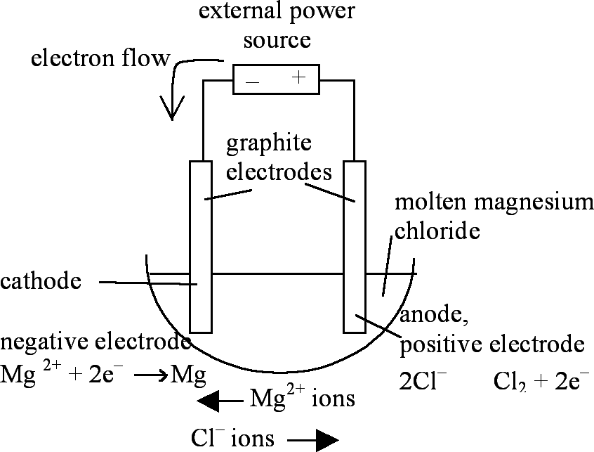 | 5
 | An electric current is passed through molten sodium bromide, using graphite electrodes.  a What particles conduct the electricity in the wires in the external part of the circuit?  b What particles act as the charge carriers in the internal part of the circuit, and in which direction do they flow?  c What substance is produced at the cathode  d Give the half equation that occurs at the anode. Is this a reduction or an oxidation reaction?  e Explain in terms of its bonding and structure, why graphite can be used as an electrode. | a the delocalised electrons  b positive and negative ions  - Na⁺ ions move towards the cathode (negative electrode)  - Br⁻ ions move towards the anode (positive electrode)  c sodium metal  d 2Br⁻(l) → Br₂(g) + 2e⁻ - oxidation  e Graphite is a covalent network substance made up of layers of carbon atoms covalently bonded together. Each carbon atom is bonded to three other atoms, leaving one electron per atom that is free to move between the layers. These delocalised electrons are able to move under the influence of an electric field. That is, graphite is an excellent conductor of electricity. Because of the strong bonds holding the carbon atoms in the layers, graphite has a high melting point and so remains a solid when placed in the molten ionic salt. Graphite is also reasonably unreactive and so does not react with the chemicals in the cell. | 5

